# Borg Civil Fleet Management System

Proposal Document

# Borg Civil Australia Pvt Ltd - Bringelly, NSW



# Table of Contents

|  |  |  |
| --- | --- | --- |
| S. No | Modules | Page No. |
|  |  |  |
| 1 | Introduction | 3 |
|  |  |  |
| 2 | Challenges and Proposed Solutions | 4 |
|  |  |  |
| 3 | Sitemap | 5 |
|  |  |  |
| 4 | Process Flow Diagram | 5 |
|  |  |  |
| 5 | Scope of Work | 9 |
|  |  |  |
| 6 | Key Stakeholders | 20 |
|  |  |  |
| 7 | Architecture Diagram | 23 |
|  |  |  |
| 8 | Deliverables | 23 |
|  |  |  |
| 9 | Infrastructure | 23 |
|  |  |  |
| 10 | Matrix (Project and Escalation) | 24 |
|  |  |  |
| 11 | Communication Plan | 25 |
|  |  |  |
| 12 | Project Management Process | 26 |
|  |  |  |
| 13 | Completion Criteria | 26 |
|  |  |  |
| 14 | Commercial Proposal/Estimation | 27 |
|  |  |  |
| 15 | Payment Plan | 29 |
|  |  |  |
| 16 | Assumptions | 29 |
|  |  |  |
| 17 | Project Change Control Procedure | 30 |
|  |  |  |
| 18 | Company Profile | 30 |
|  |  |  |
| 19 | Glossary | 31 |
|  |  |  |

# Version History

|  |  |
| --- | --- |
| Version# & Date | Change Initiated |
| 3.0 | Dec 14, 2016 | Third Version |
| 2.0 | Dec 11, 2016 | Second Version |
| 1.0 | Dec 09, 2016 | First Version |

# **Introduction**

Borg Civil Australia is a private enterprise excelling in its functions since 2008, specialising in excavation, truck hire, plant hire and varied works such as site cuts, spoil removal, site remediation and land clearing. They have a wide range of advanced machinery and equipment’s to meet and exceed the requirements of projects of all scales and complexity.

The resources of the enterprise are as follows:

* The current number of employees is 15.
* Number of driver 46 (12 full time and rest is on requirement basis)
* Machines are approx. 60 in numbers
* Trucks are approx. 80 in numbers
* 300 docket in a week and 50 docket in a day

The new application will effectively manage their day to day running of all operations, services and jobs. This document with highlights on proposed solution focuses on key modules such as:

* Dashboard (Web Application)
* Client Management
* Import/Export Feature
* User Management
* Role Configuration Module
* Report Module
* Configuration
* Dashboard for Web Application & Android Tablet
* Booking Management (Work/Job allocation)
* Invoices and Billing
* Workshop (Services & Repair)
* Fleet Management (Equipment, Attachment, Truck)
* Enquiry & Quote Module
* Compliance Module

**Future Scope:**

* Workshop (Fully Automated)
* Supplier Module
* Fuel Tank Module
* Legacy Data Migration
* Payroll Management

# **Challenges & Proposed Solution**

# The current process is hindering the business profitability. It is a manual process hence changes of human error and inaccuracy is higher leaving the system less efficient. At every stage verification and data checks makes the process highly time consuming. Hence, most of the time and resources are exhausted in job allocation, verification of data and to resolve daily issues which otherwise can be resolve more efficiently and quickly by the automated process.

Current manual process in an obstacle in the profitability as;

* Highly person dependent system due to manual working process
* Probability of human errors at each step may add to loss of profit, time and productivity
* Manual work adds time overhead
* Delay in allocation of job / utilization of plant
* Access cost paid for tip off sites due to manual error
* Incorrect invoice result in either loss or credentials with clients & required senior resource time to verify each of the invoices.
* More staff required for managing all documents and manual processes
* Inaccuracy of data leads to wrong result
* Mostly invoice mistake is due to the communication gap or misunderstanding
* Delay in tracking docket forms

The automated system and robotic web application can add immense efficiency and profitability to the business. It will help to achieve results and meet goals of Borg Civil and provide the Key benefits like,

* Real time tracking and proper management of work/job and employee
* Faster turn-around-time (TAT)
* Manage job allocation process
* Manage invoices and billing with proper accuracy and verification
* Manage damages and issues easily
* Manage documents and contract at one place
* Manage staff and other users
* Cutting operation cost and overheads
* Timely alerts and notifications
* Improve workshop efficiency
* Greater transparency and visibility of entire operation at a glance via dashboard
* Accuracy in reports and analytics

# **Sitemap**

This include the main modules of the Fleet management system based on current scope

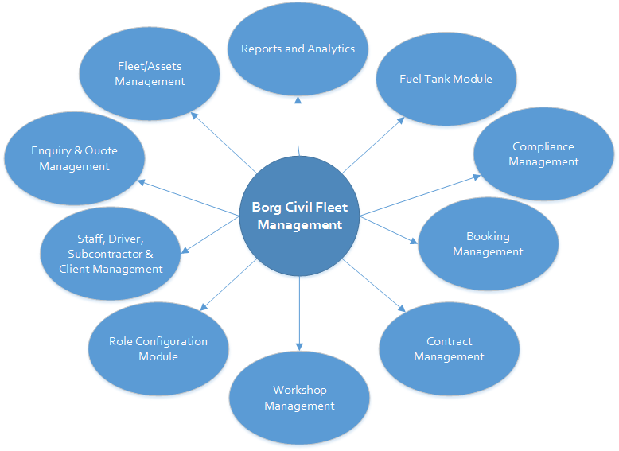

# **Process Flow**

This includes the high level process flow of the system with New Software 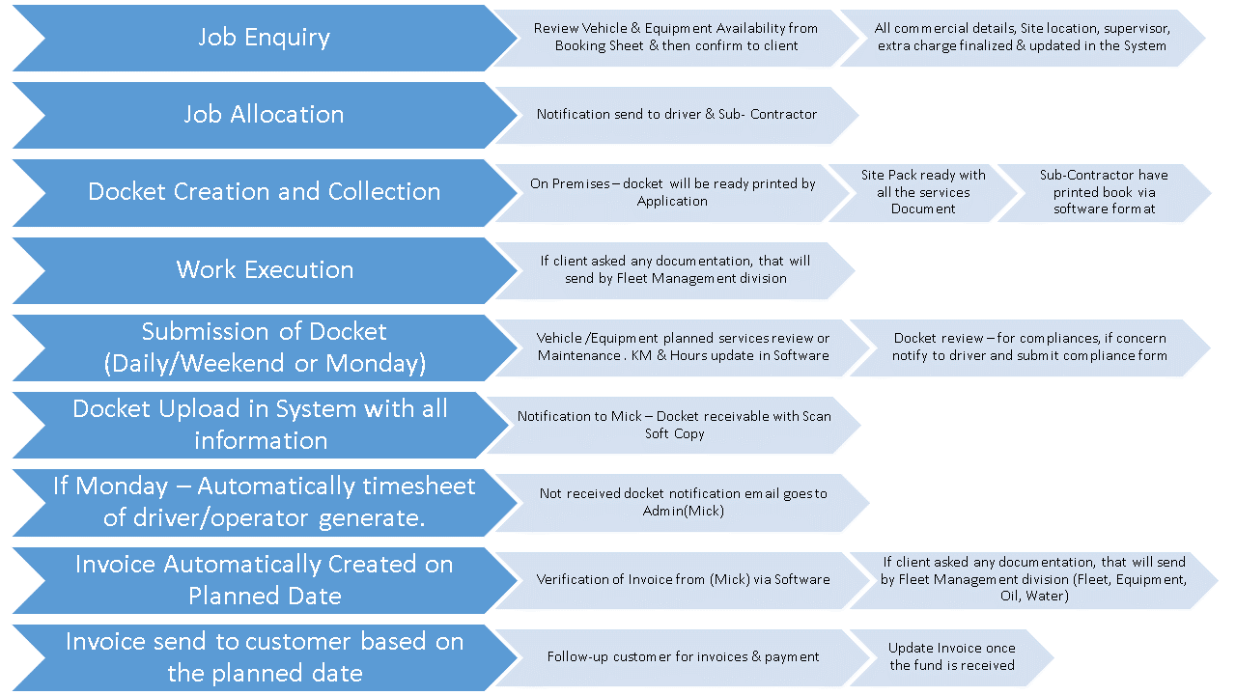

**Truck Hiring Process - Currently**

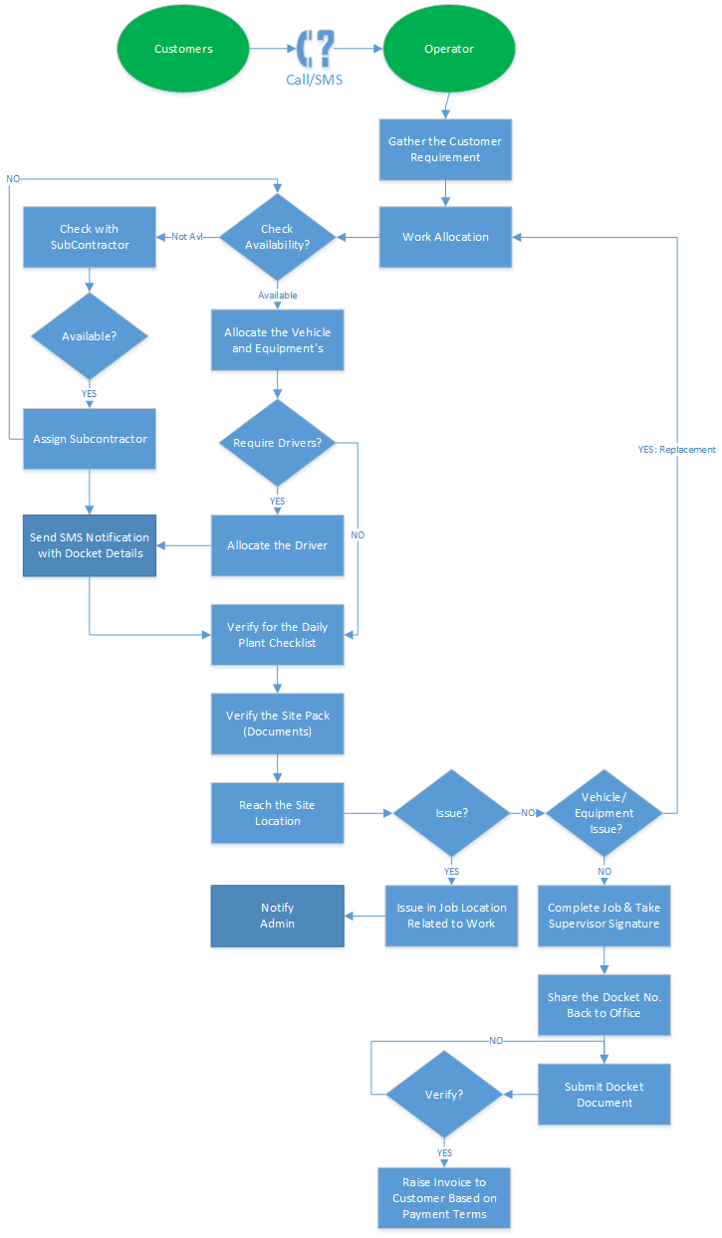

* Client hire on the basis of work type i.e. hourly, contract and tonnage
* Currently Borg Civil have X Number of Trucks and on the basis of availability they confirm for the booking
* If truck is not available in their yard, then they hire the trucks from their sub-contractor
* The requirement can include driver too. If driver is not available at Borg Civil for particular truck, then the subcontractor driver can be called for that job
* If there is any issue faced in truck, then driver called Borg Civil and notify for the issue. Billing is stopped from that moment and after that Borg Civil will send someone for repairing or replace the truck if available
* Borg Civil charge the extra charges with the truck if required like
  + Water Tank, Toll
  + Attachment or additional request of client
* Truck also required docket number of daily basis (based on the uses). Subcontractor already carry the docket book and they use the docket form for the job. Borg Civil Driver get the Docket form ready in the premises.
* Subcontractor or Driver take signed off from client supervisor and submit back to Borg Civil office. Subcontractor driver normal submit whole week document during weekend or Monday.
* Once they submit the docket number then it is updated in Diary.

**Machine Hiring Process**

* Machine, client hire for hourly, contract, tonnage basis. Machine shift to client location by “Truck Loader”
* Currently Borg Civil have X Number of machines and if required they will hire the machines from sub-contractor
* Machines required operator too. Only specific skillset operator can operate particular machines. Rarely client will have an own operation in which he just takes the machines on the rent. If machine stopped working, then operator called Borg Civil Company and notify.
* Billing is stopped from that moment and after that Borg Civil will send someone for repairing or replace the equipment if available in spare
* We charge the float charges with the machines when billing to customer (1 time or 2 times) depend on the contract or relationship. Sometime we will shift 2 machines or more with the truck loader.
* Client can take machines for few hours per day or for 1 week and may be use 20 hours. All the charges are depending on the commercial define
* Machines also required docket number of daily basis (based on the uses)

**Workshop Service Process**

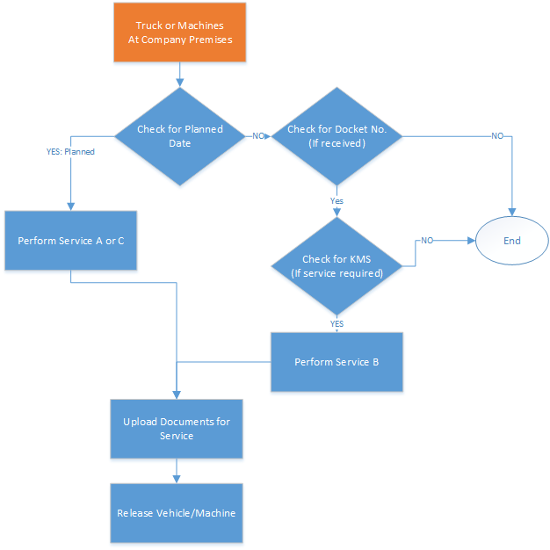

# **Scope of Work**

**1. Dashboard:**

Dashboards often provide at-a-glance views of KPIs (key performance indicators) relevant to a particular business process (e.g. sales, notifications, daily progress or reports)

* **Features and Functionality**
  + Notification:
    - Vehicle insurance reminders (Before 2 weeks)
    - Vehicle not used from last 1 month
    - Driver work for Borg Civil (Free time)
    - Missing docket, no
  + Available equipment
  + Equipment’s under maintenance
  + On leave report
  + Pending and due invoices
  + Services machines/vehicles overdue
  + Equipment’s consumption
  + Identify the key positive & negative factors
    - TOP paid client/contract
    - Less paid client/contract
    - Most used & unused vehicle/machines
    - Best utilise/utilise resource

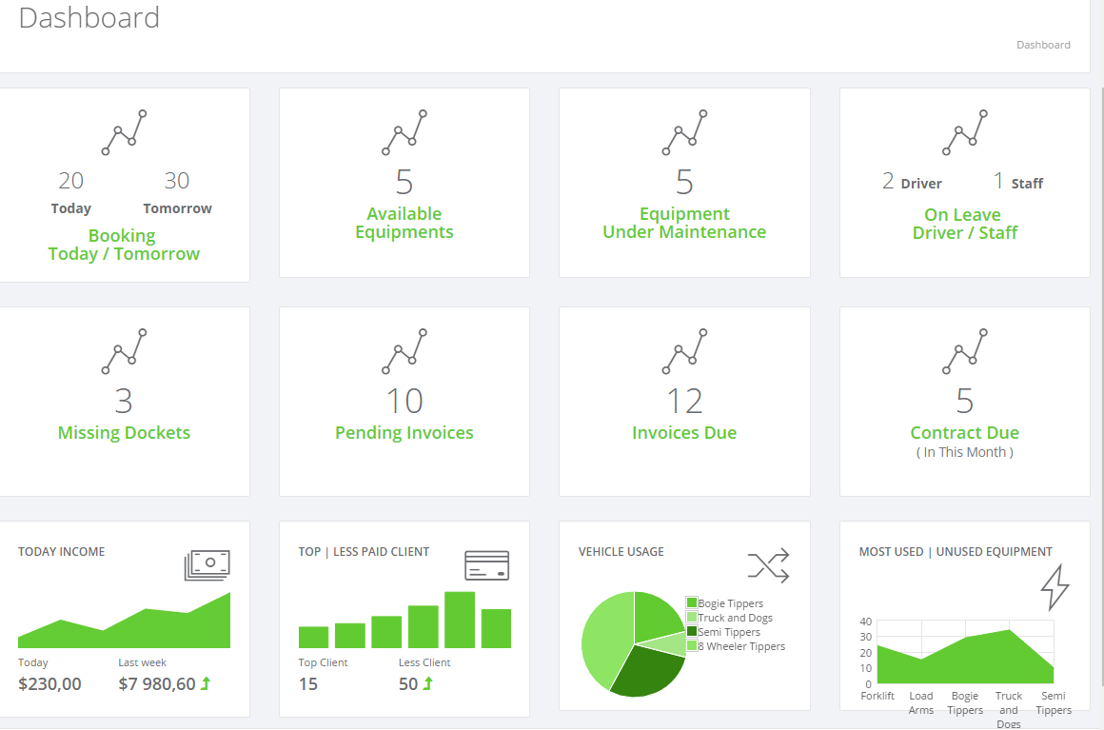

**2. Client Management:**

In this section, all the details of client will be managed as shown below.

* **Features and Functionality**
  + Basic information (Personal/Address/Billing)
  + Contact person details (Key Contact Person, Supervisor)
  + Rate card of customer (machine, vehicle)
    - Including/Excluding Toll Tax
    - Day / Night Rates
    - Including/Excluding Float charges
    - Work Type (material type- tipping)
    - Contract/Hourly/Tonnage
    - Waiting Time
  + Contract management for each client (Wet and dry hire)
    - Manage payment terms (Weekly(Monday), Monthly (24 to 23 of month)) + Net 30/45
    - Contract renewal period (Yearly)
  + Work job wise status
  + History (Monthly billing with customer)
  + Manage billing & invoicing details, tax details
* Site location

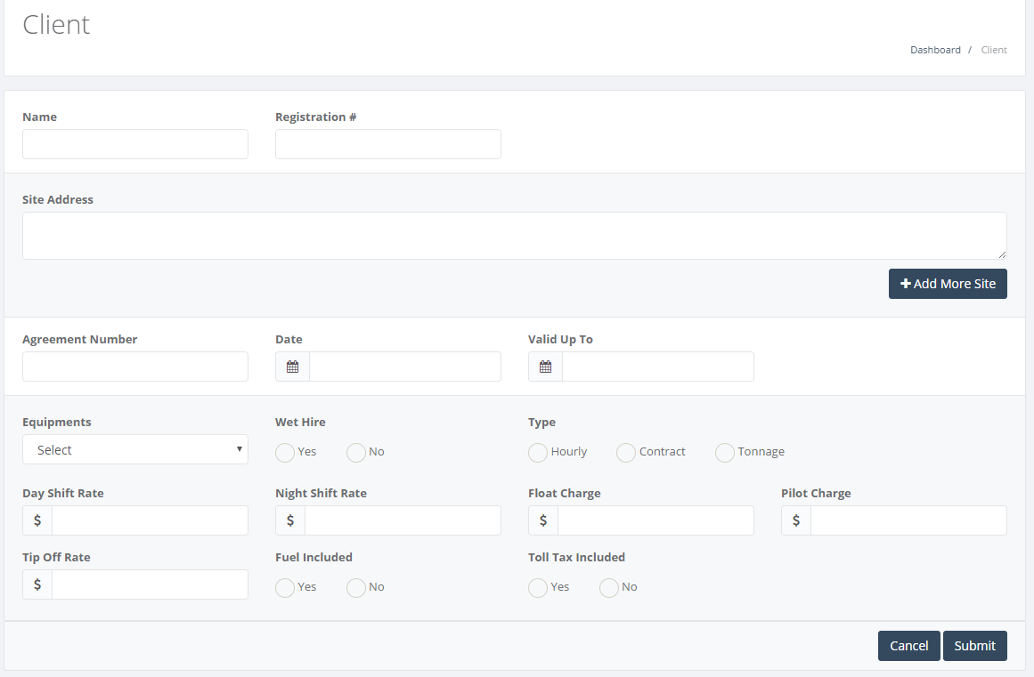

**3. Import Module**

* Important current data from CSV
* Customer
* Driver
* Operator
* Equipment
* Vehicles
* Supplier
* Sub-Contractor details
* Sub-Contractor Vehicle
* Sub-Contractor Equipment
* Sub- Contractor Drivers
* Sub- Contractor Operator

**4. User Management:**

Manage each user with all its details require within system.

* **Features and Functionality**
  + Staff Management
    - Manage staff details such as personal etc.
  + Driver Management
    - General information(Personal/Address)
    - Upload license card
    - Upload white card
    - Vehicle compatibility (as per our current Rego)
    - Upload health guidelines (review)
    - Upload drug and alcohol form
  + Subcontractor Management
    - General information (Personal/Address/Billing)
    - Manage their driver details
    - Manage vehicles details
    - Manage machines details

**5. Role Configuration Module**

* Create all the Role in the System
* Assign different role to users
* Assign privileges of module to each users

**6. Reports and Analytics:**

Each reports will be generated based on day, month or year

* **Features and Functionality**
  + Sales reports
  + Vehicle and machines usage reports
  + Booking/Work allocation reports
  + Date wise reports- job orders
  + Vehicle availability report
  + Subcontractor reports
  + Overall vehicle and machine efficiency report
  + Driver specific reports
  + Client or job specific reports
  + Performance tracking

**7. Configuration & Master:**

This section will manage the modules which are fixed entry into application and accordingly it

will be used in all the application.

* + Master creation
  + Rate cards
  + Checklist parameters
    - Equipment’s checklist
    - Workshop checklist
  + Billing information
  + Logo and address
  + Email
  + SMS API Configuration

**8. Dashboard (Tablet)**

Same as mention in the point 1 but it will develop for the **Android TABLET**

**9 & 10 Booking Management (Work/Job Allocation) – Web & Tablet:**

* **Process**
  + Work allocation is the process in which Borg Civil user gets the call from the clients and gather his requirement on daily basis
  + Accordingly, Borg Civil confirm the client about the availability of equipment’s and allocate to their staff or sub-contractor
  + During gathering of requirement, user take the details about supervisor, site location, vehicle/equipment required, timing and job type & rate. They also discuss about the extra charges/cost if any (toll, water, late night etc.)
  + Once client confirms the order, user sends the SMS to staff/subcontractor with all the required details
  + Driver/operator take the docket from office and then go for the work
  + Once Job is completed, then they will submit the docket number in the office. Sometime docket will be submitted in 3-5 days via sub-contractor
  + If driver found any issue on site, he will call back to the responsible users (Mick and Jerry) for the solution and accordingly the replacement or other vehicle to repair will be sent
  + They do not bill to client for that time if issues occur from Borg Civil
  + Once docket number is signed off after work done from supervisor, then they submit back to office
* **Features and Functionality:**
  + Manage work allocation sheet for all the jobs
    - The planned schedule for next day is managed based on client’s requirement via. Job booking form
    - Initial information will be filled for the requirement and accordingly SMS is sent to the driver or operator

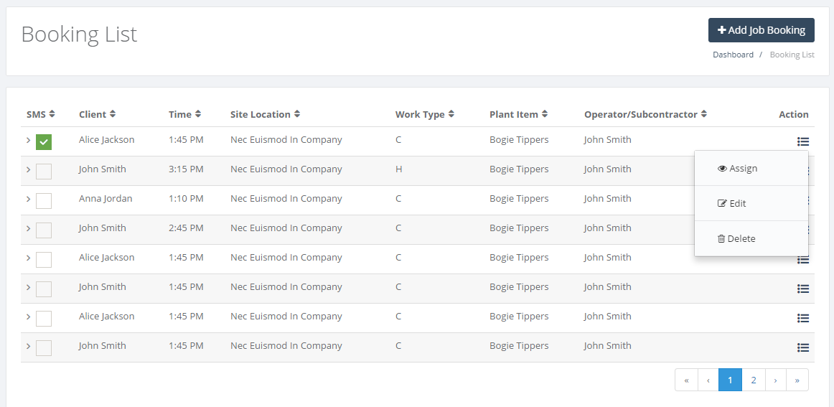

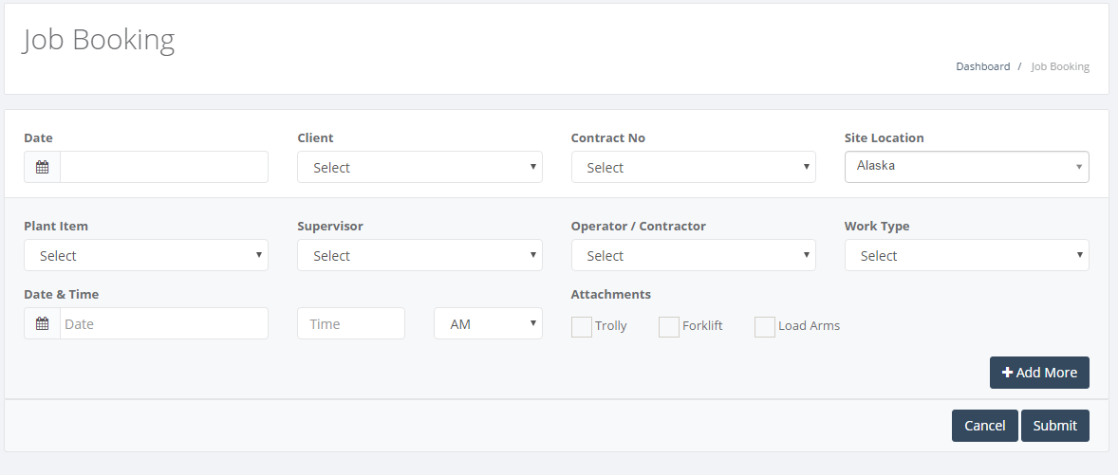

* + - User can check for all the bookings and assign the driver or operator based on availability of equipment

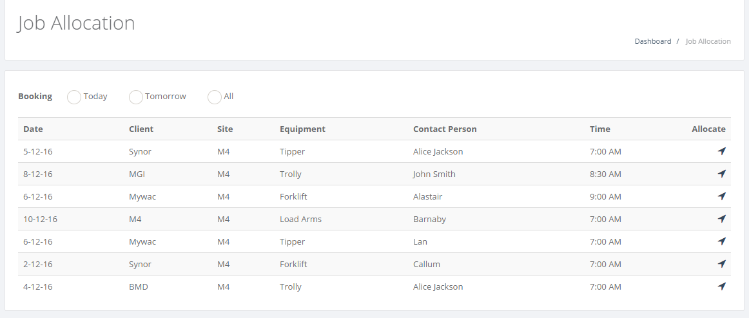

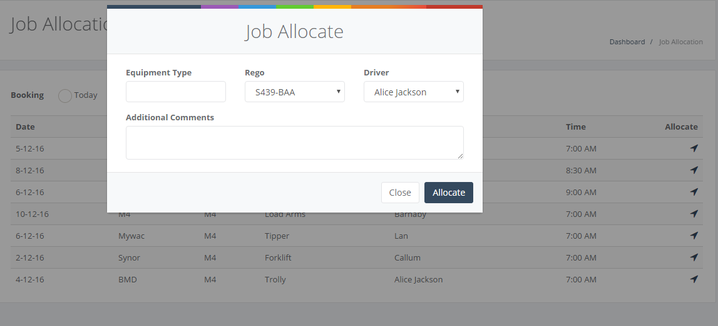

* + Manage docket formats rep
    - For each job, there is docket number
    - Once job is allocated, then this receipt will be filled with all the details which has some different formats. There will be 3 docket format for the different types of work. Print the receipt of docket from system.
    - Docket form need to submit back once signed off by client
    - Sub-contractor will have this docket receipts which they can directly signoff with the clients and submit back to Borg Civil within week time

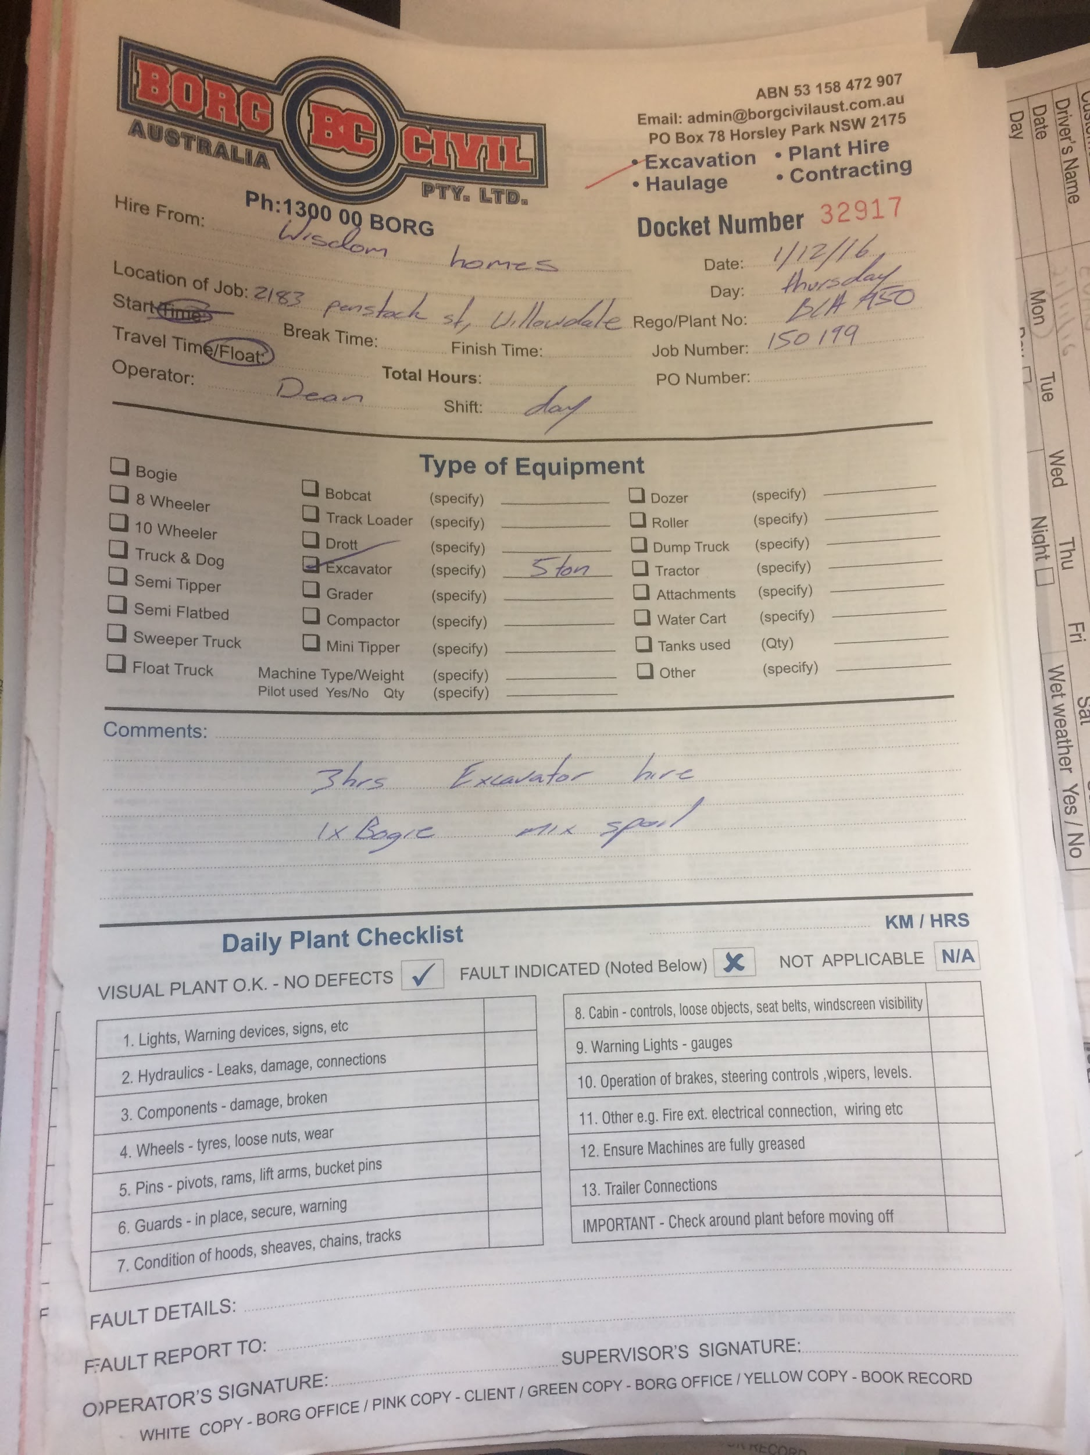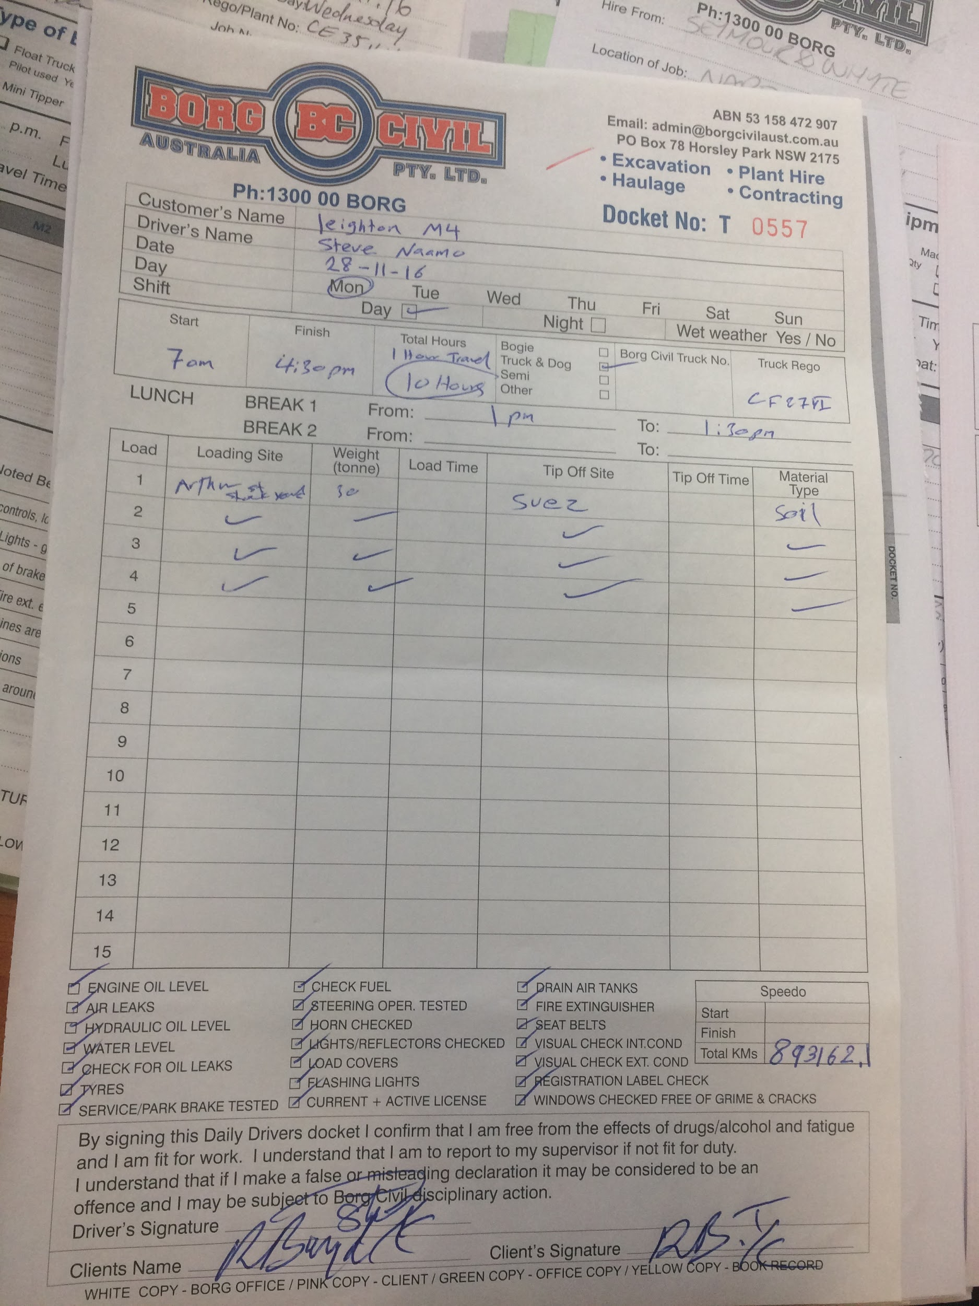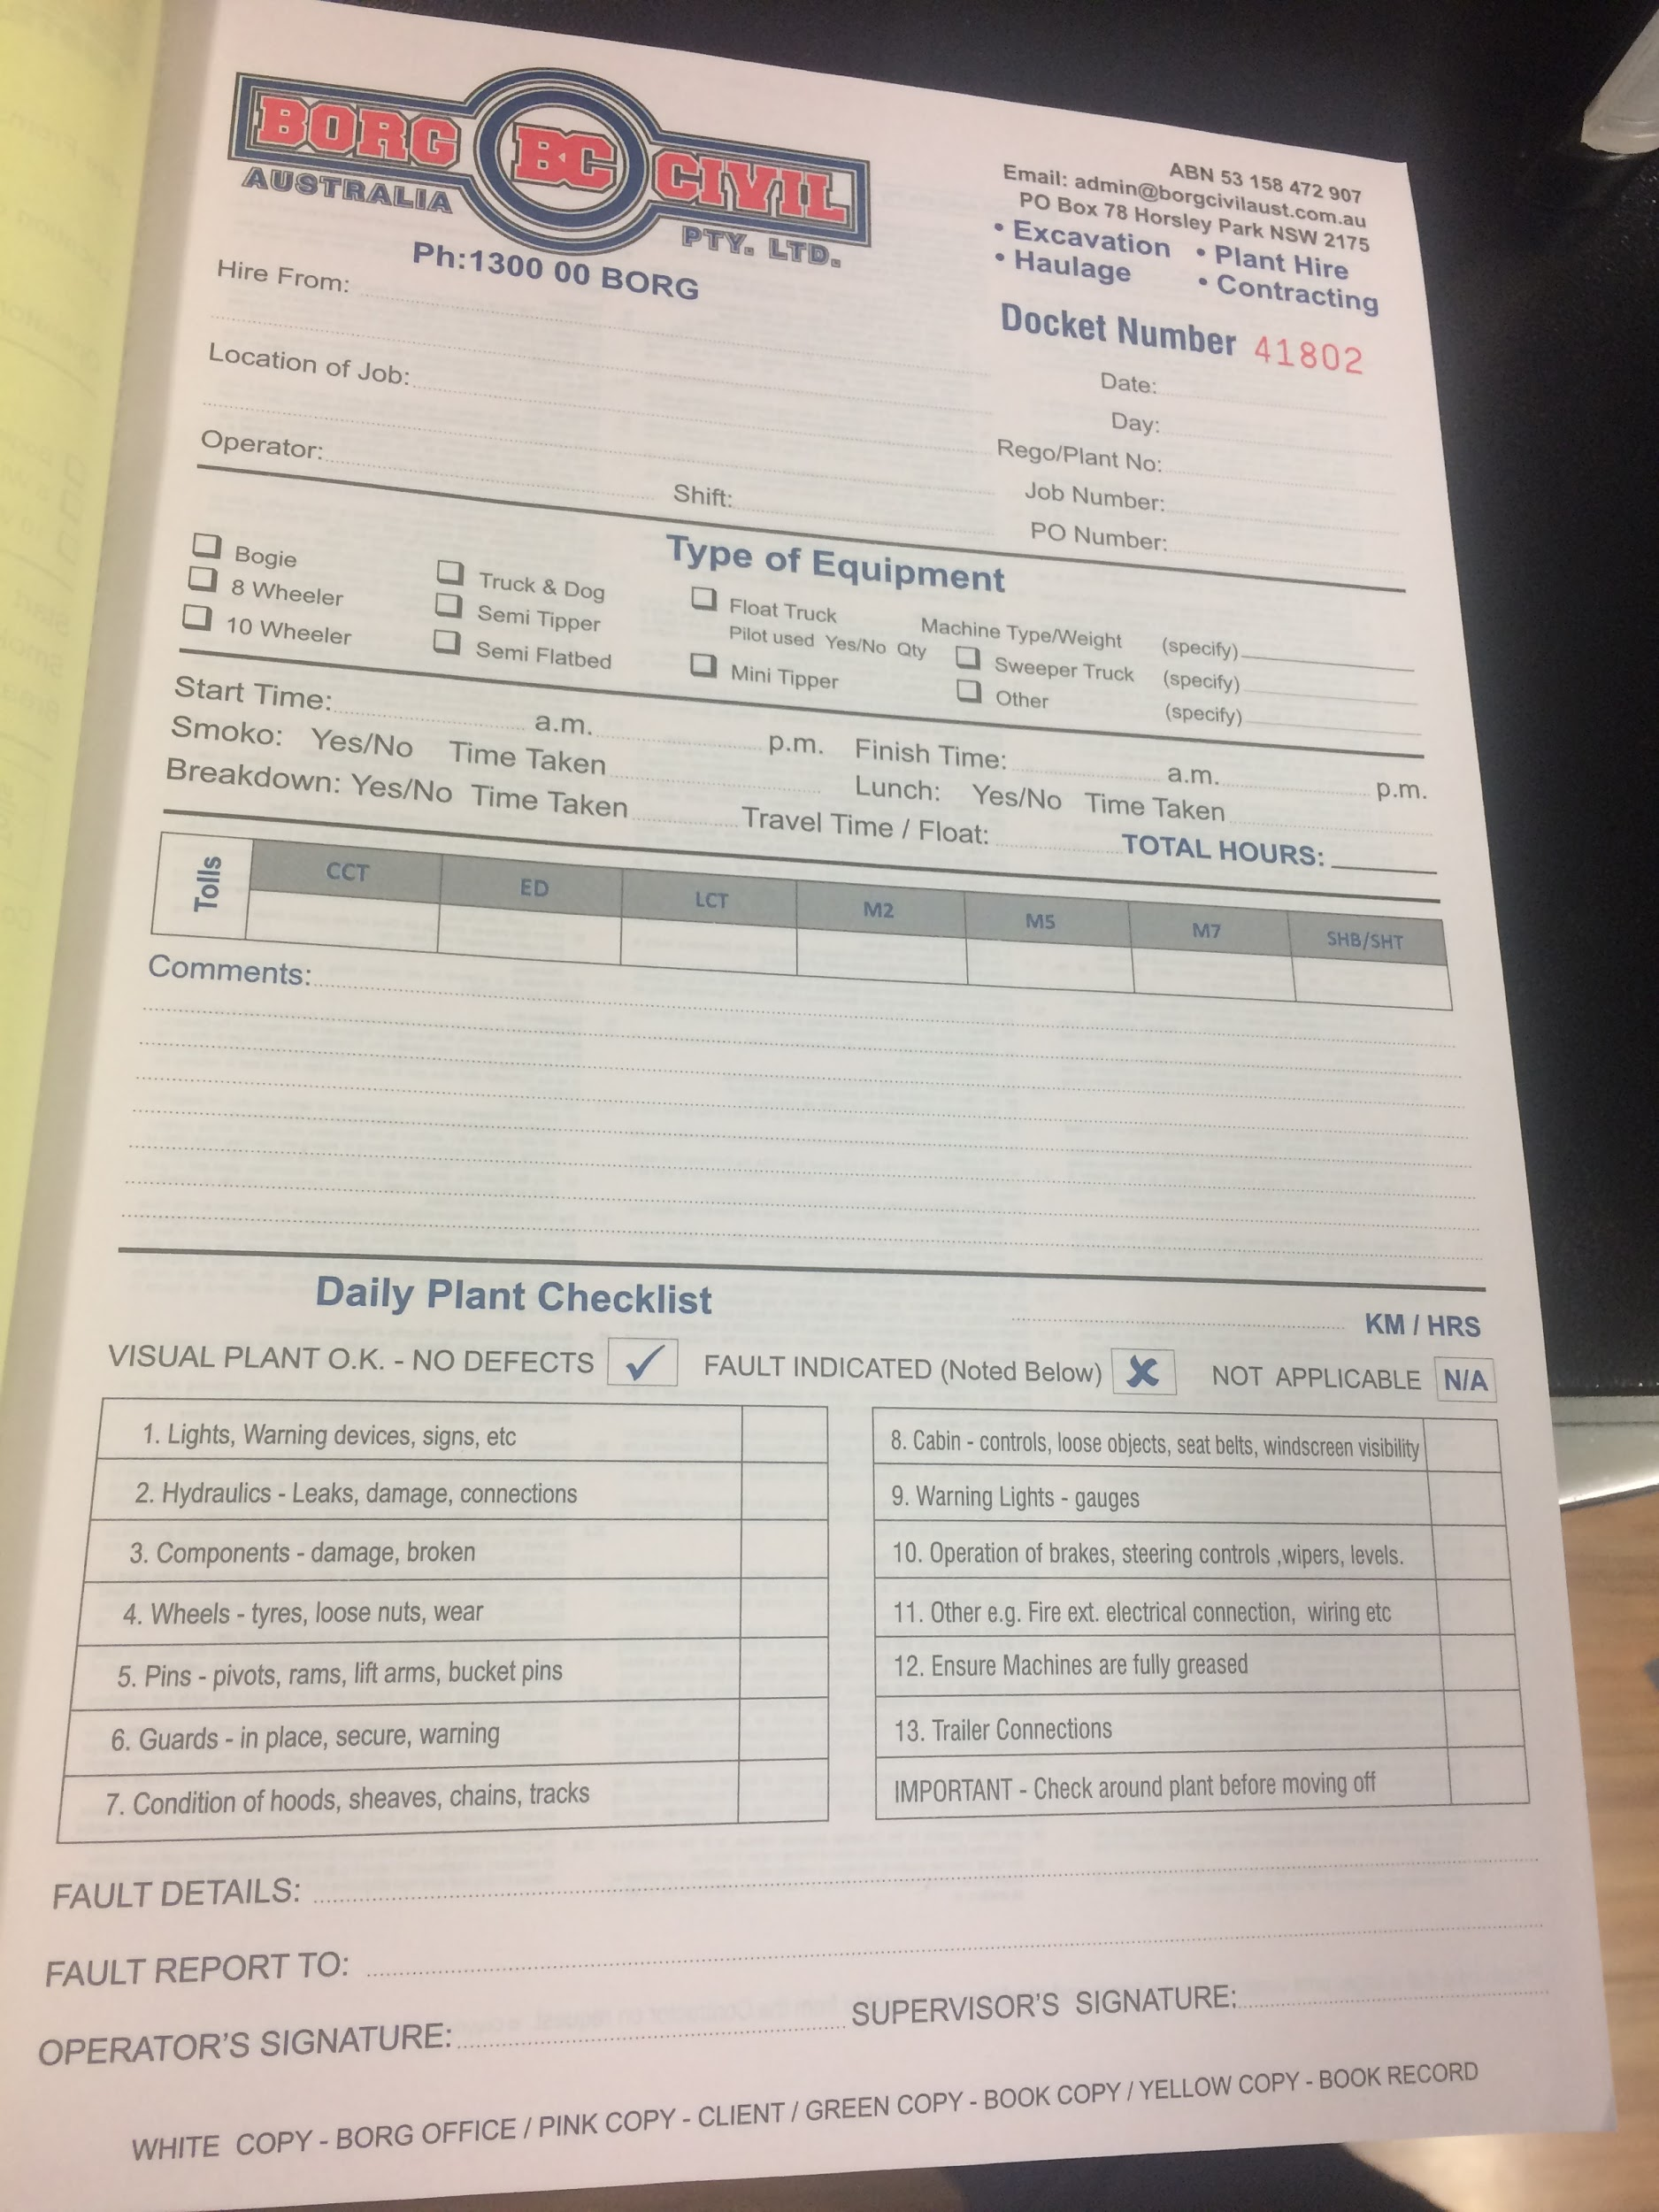

* + - Daily plant checklist are the measures which driver needs to take care before taking the plant to the workplace
    - Start Time: Work started at client’s location
    - Travel Time: Included for the driver but not included in client invoicing
  + Manage status of each docket number

**11. Invoices and Billing:**

User can manage invoices and billing for each work done

* **Process**
  + User collect all the docket on Monday
  + They arrange them based on the client, sites and dates
  + Share it with other users to mark as received
  + After that they share it with finance division for the billing
  + Division will feed all the data in the MYOB and generate one invoice as per the client rate card
* **Features and Functionality**
  + Invoice Generate automatic
  + Payment chasing to client
  + Edit Invoice Sections
  + Invoice Template
  + Credit Notes & Adjustment Invoices
  + Payment Updates in the Invoices (partial section, full payment)
  + Create Maule Invoices and Send to customer
  + Send Invoices to Customer via email
  + Merge the Invoice (last 1 month, weekly)
  + Calendar - Planned Funds Received
  + Calendar - Invoice Generation Dates
  + Reports

--Pending Invoices (Date, Weekly, Monthly)

--Payment Received (Date, Weekly, Monthly)

--Customer Wise Invoice (Date, Weekly, Monthly)

--Monthly Analysis Reports

Driver Wise

Equipment Wise

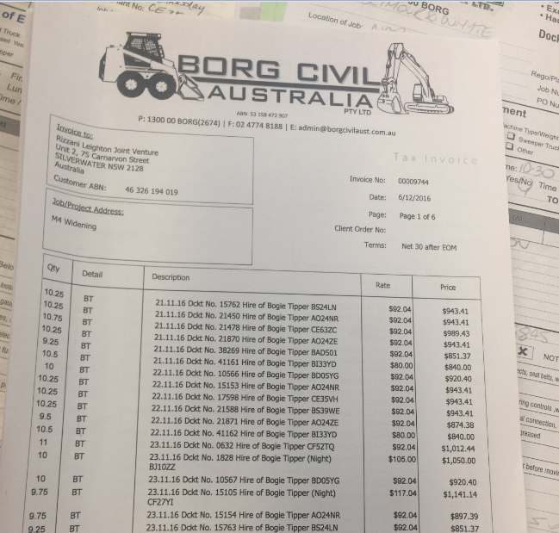 Truck Wise

**Driver Invoice**

* + - Driver create the weekly sheet currently. (Timesheet screenshot is attached).
    - We will generate this report from application and accordingly invoice will be raised for the driver

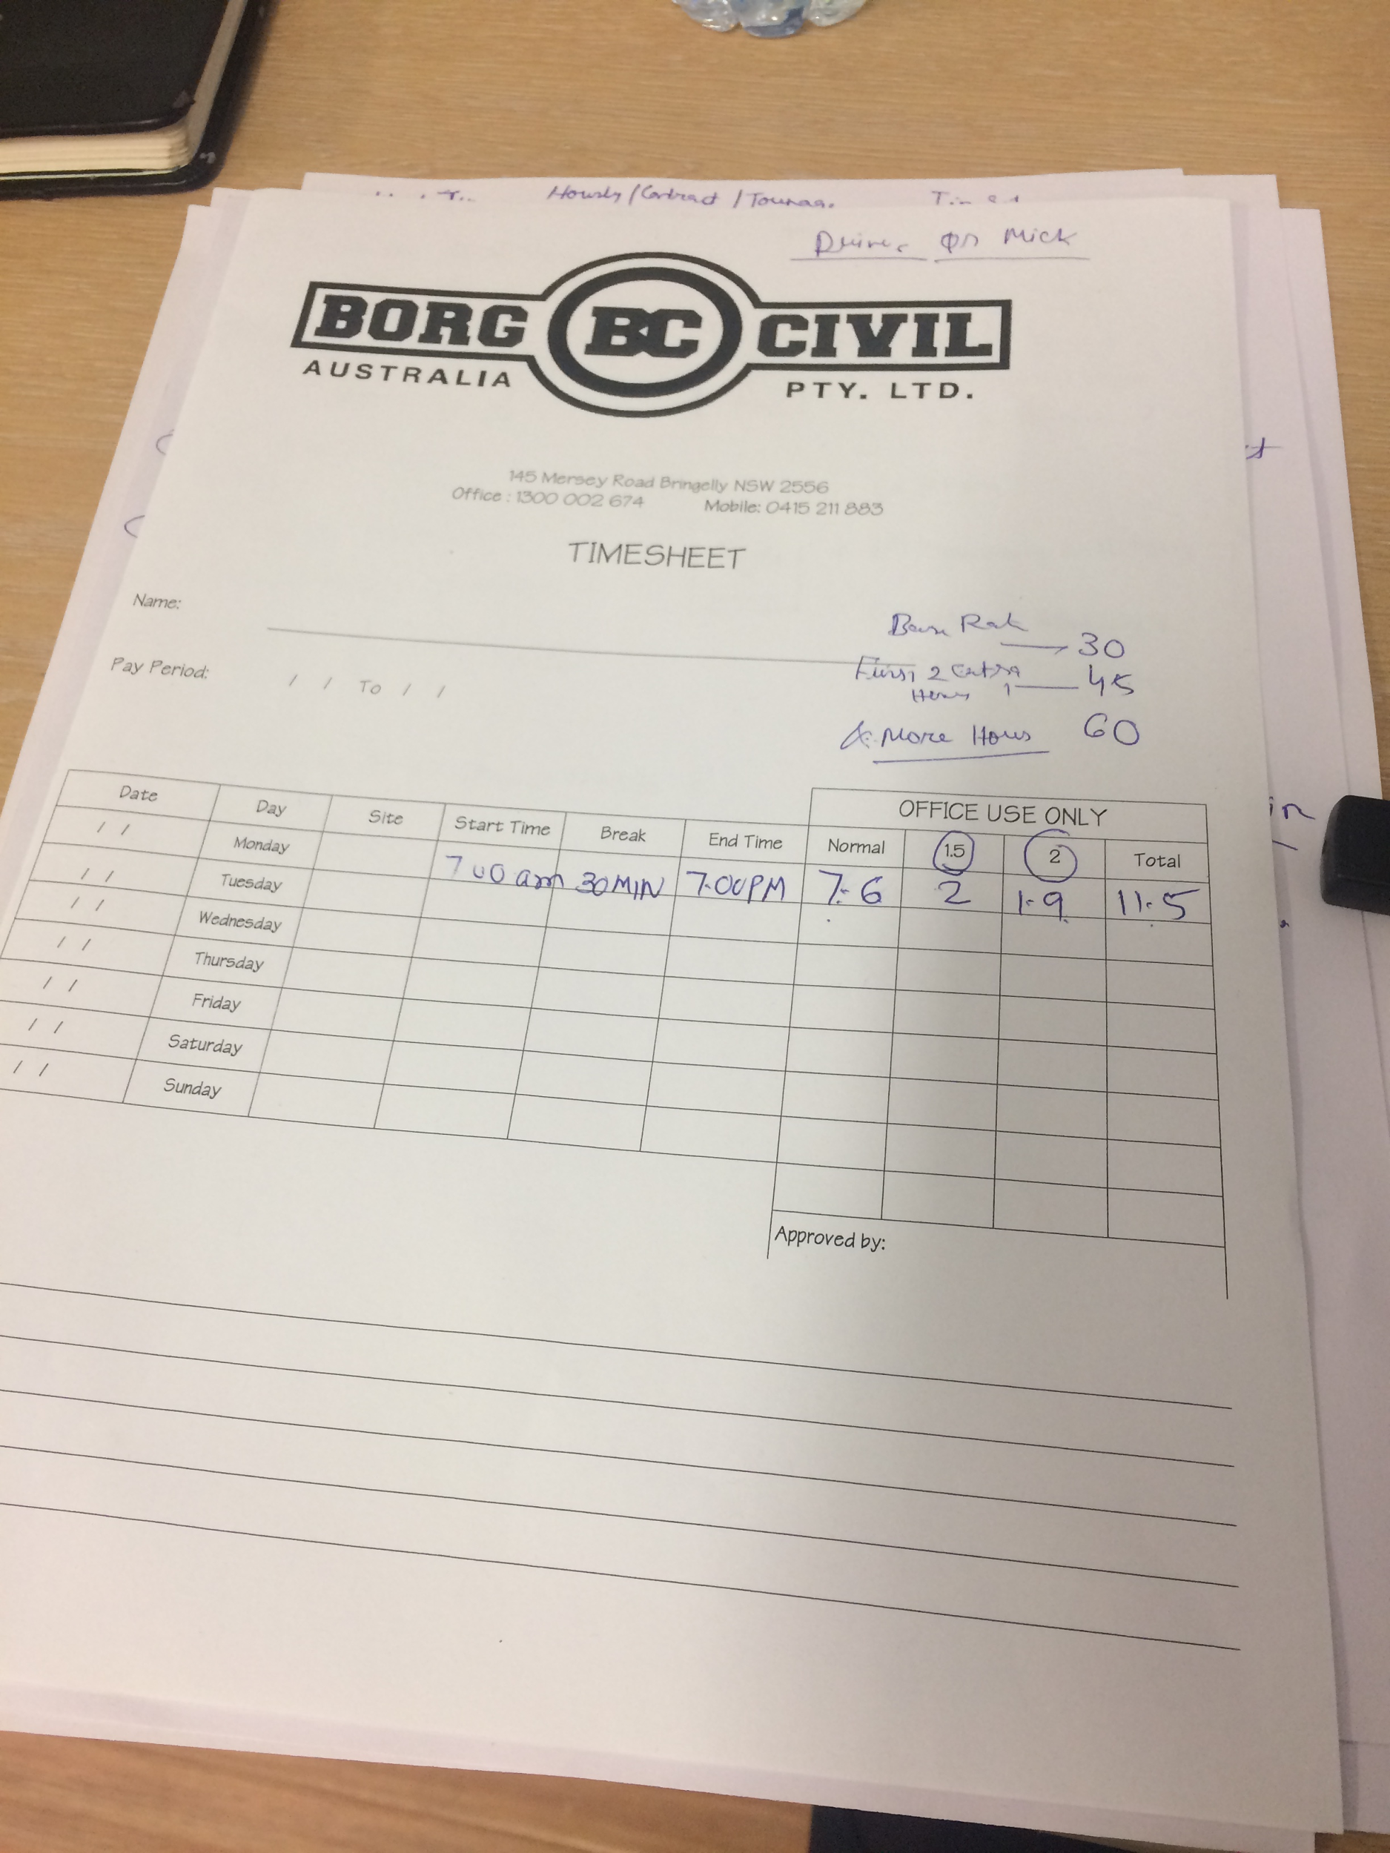

**12. Workshop Module- Services and Repair:**

All the service and repair management would be managed in workshop module. Inventory details

will be managed in inventory section where there will be alerts for the availability of equipment’s.

* **Features and Functionality**
  + Equipment’s service reports

There will be 3 types of service report which will be managed as per the below

Parameters such as;

* + - Service A- (15 days)
    - Service B- (KMS/Readings)
    - Service C- (Yearly basis)
  + Truck service & repair form

If any repair occurs, then user needs to fill the form and update the comments with the issue. This again associate with the site pack

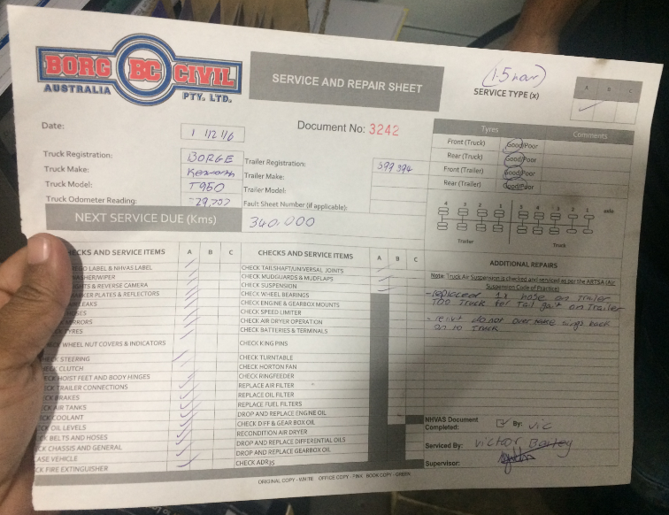

* + Machine:

Machine services occurs in every interval of time 250 hours. It will be managed using

below form

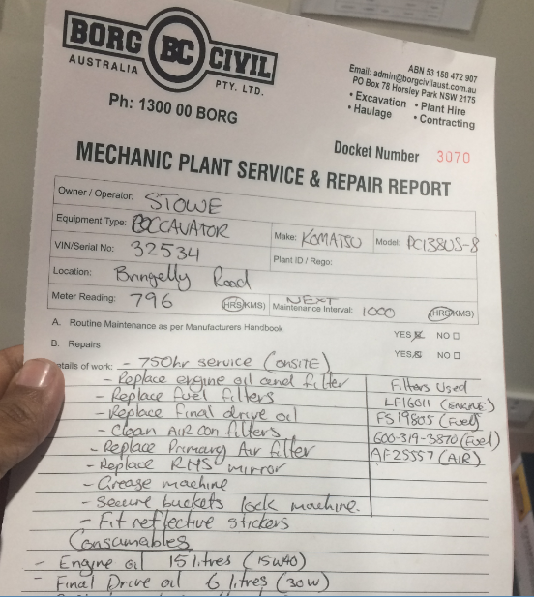

* + Job Estimates for maintenance /repair vehicles
  + Send service reminder
  + Record issues, spares parts used in against job cards
  + Planning for Equipment/ Vehicle date wise
  + Reports
    - Based on the Vehicle
    - Based on the Equipment
    - Based on the Driver (which vehicle/equipment required max maintenance)
    - Based on the Time
    - Based on the Issues

**13. Fleet Management:**

Fleet Management is a section which allows companies to manage the vehicles and machines details to minimise the risks associated with vehicle investment and efficiency etc.

* **Process**

This explains what all things can be included in the automated system as per the current process.

* + Manage site pack (trucks & machines documents)
  + List of machines and trucks details
  + Once click on the truck will allow user to view the site pack/document details
  + If any client required the site pack, then it will be directly sent to client from system
  + Some client requires the service documents for 1 or 5 months or 1 year with site pack. So there will be option to select documents
  + Service manager will upload all the services and repair documents in the system
  + Services and maintenance are managed every day based on the comments of driver and in the evening/morning this maintenance work starts.
  + We only need to keep last services document details
  + Subcontractor sends document via. Email or provide hard copy of services document. This we will scan in the System
* **Features and Functionality**
  + Trucks Details
    - Registration details
    - Insurance renewal date
    - Site pack
      * Document for each vehicle (Upload and download)
      * Mass permit for some areas (if required)
    - Services documents (3 types A/B/C)
    - Track vehicle readings
    - Risk assessment sheet

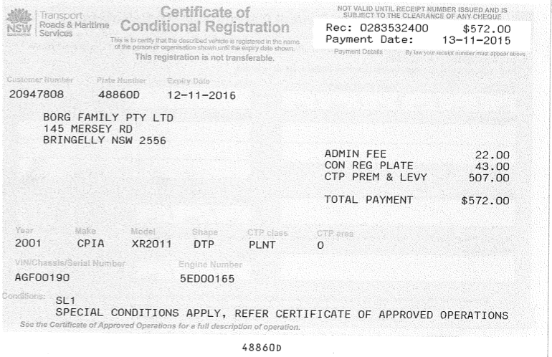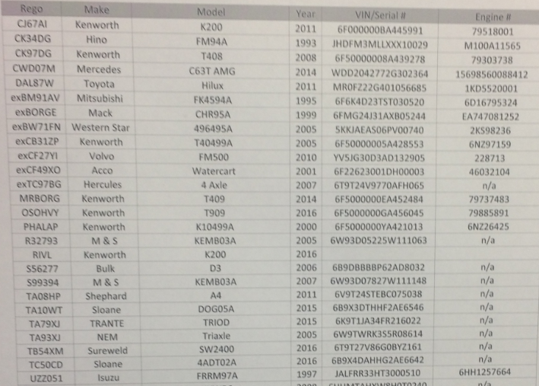

* + Machine
    - Registration (May/May not be)
    - Insurance renewal date (Quarterly/Half yearly/Yearly)
    - Services documents
    - Site packs
      * Document management for each machines (Upload and download)
      * Mass permit for some areas (if required)
    - Track machine readings
    - Risk assessment sheet

**14. Enquiry & Quotation:**

* **Features and Functionality**

All the client enquiry can be managed in this section where it will include

* + Manage each enquiry for all the leads and its status
  + Commercial offers and feasibility checks
  + Manage quotation details
  + Send emails of Pricing
  + Tracking of Quotation
  + Analysis of Accepted/Rejected Quotes

**15. Compliance Management:**

In the compliance, Borg Civil manages the 2 important things driver awareness and government norms.

* **Process**

Driver Process: They should take proper break during work (as per government chart) such as example 15 min break in 2 hour

* + Driver submit docket number back to office and they review the docket number
  + User will then discuss with driver for the breaks
    - * If taken update the format (mentioned below)
      * If not taken properly then they have to fill non -compliance form and submit it to government
  + Office user will talk to driver on daily basis and educate them

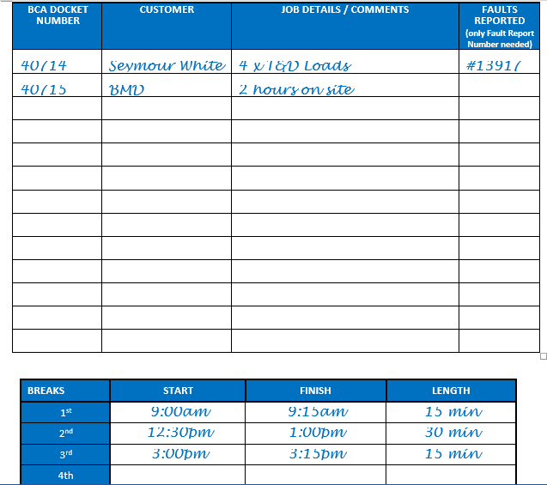

* **Features and Functionality**
  + View the daily docket list
  + Track objectives and targets - Update the interval of driver and record for compliances
  + Competences awareness and training
  + Monitoring of drivers and its action steps
  + Non-compliance reporting
  + Manage policies, manuals, procedures and instructions (work instructions)
  + Send report to Board about “Driver, Regular Observation Positive/Negative” in compliances

# **Key Stakeholder’s**

**Application Users:**

1. **Michael(Admin):** Responsible for Job allocation/Review the dockets/Invoicing review
2. **Jerry (Job Allocation Manager):** Responsible forJob allocation/Execution
3. **Brandon (Compliances Manager):** Responsible forCompliances management/ Services and Maintenance of Vehicles & Equipment’s
4. **Suzy (Fleet Manager, Customer Documents Requirement)**: Responsible for Fleet Management
5. **Terry(Admin)**: Overall Business Tracking (Legal, Contract, Accountant)
6. **Prateek(CA):** Key Point of Contact- Accounting Stuff
7. **Nadeesh:** Responsible for Invoicing
8. **Angela:** Responsible for the Payment Chasing & Notes (Invoice /Credit note by Tanya)
9. **Crystal:** Responsible for Docket arrangement, KMS/HRS Details, Driver details

**Admin:**

* Manage configuration (Roles and permissions and masters)
* Manage work allocation
* Manage workshop
* Manage users and clients
* Notification and alerts
* Reports and analytics
* Message to all the Driver/Operator (Group Message via SMS API)
* Enquiry and Quote Management
* Import and Export Customer, Supplier, Fleet
* Admin will get a final invoice for approval and once approved, then invoice email send to client.
* Notification of Daily basis docket issue/comments analysis & Concern

**Work Allocation Manager:**

* Enquiry and quotation management
* Manage jobs requirement
* Commercial rate finalization with Customer
* Allocation of vehicle, equipment’s (Work allocation sheet), Driver
* Management of Vehicle & Machine availability (on premises/sub-contractor)
* Sending SMS Notification to driver /operator for Job Allocation (including sub-contractor)
* Docket creation and printing
* Review report & alerts

**Workshop Module - Service and Repair**

* Vehicle & Equipment Service/Repair Calendar
* Regular service and repair management (Vehicle) -
  + Service A- 15 days
  + Service B- KMS/Readings
  + Service C- Yearly basis
* Equipment services & repair management
* Get reports for service and repair
* Get the alerts for services today and next week
* Red flag alert vehicle/equipment missed the services or services long due
* Service History of Vehicle and Equipment
* Labour time analysis on each Vehicle

**Fleet** **Manager:**

* Fleet/assets management
  + **Borg Civil & Subcontractor** 
    - * Manage Vehicles (Site pack) Details
      * Manage Machines Details
      * Fleet manager send all this document to customer as per the needs
  + Fuel management
  + Government format management

**Assistant:**

* Manage all the Client
* Sub-contractor management
* Docket management- Manage 3 formats (Tip, Vehicle etc.)
  + Docket creation and print
  + Update on job no. (No. Of hours worked, break time, comments)
  + Upload docket copy
* Driver Management
* Collect all the docket, Upload in the System, upload all the details in the System, write all the comments & concern related to docket

**Account Manager:**

* Manage payment terms of each client and subcontractor
* Invoice management
* Send invoices and manage status for the payment
* Manage credit notes
* Fuel management
* Payroll Management

# **Architecture Diagram**

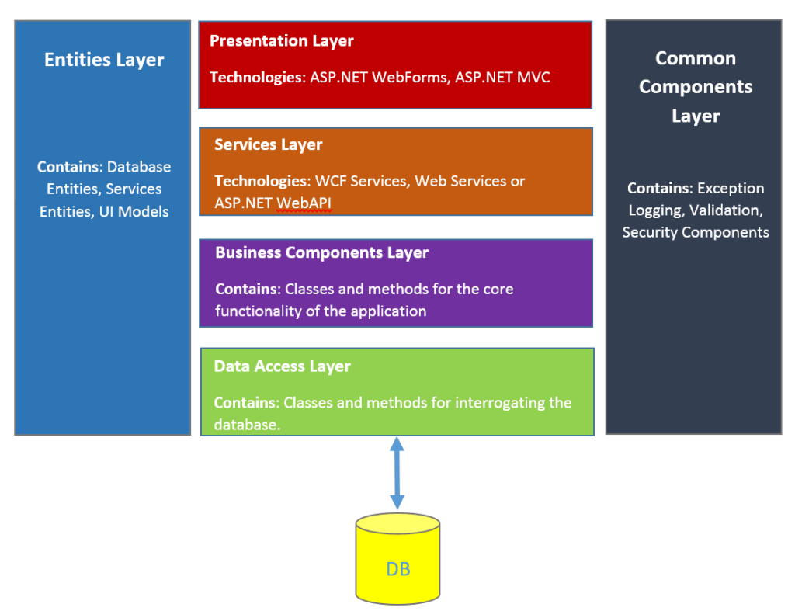

# **Deliverables**

* Cloud Based Web Application
* Android App (Compatible with Tablet)

# **Infrastructure**

**Web Application**

* MS Technology/MEAN Framework
* MS SQL SERVER / MYSQL
* JS Script: Angular JS/Node.JS

**Mobile App**

* Technology: AndroidApp Samsung (Bigger size view).
* Web services: MS SQL
* Compatible on Tablets and Android phones

**Third Party Integration**

* MYOB
* SMS Gateway

# **Matrix**

The Project Manager will ensure that the project will be delivered on time with quality standard.

He ensures the project is effectively resourced and manages relationships with a wide range of groups (including all project contributors). The Project Manager is also responsible for managing the work of consultants, allocating and utilising resources in an efficient manner and maintaining a co-operative, motivated and successful team.

Below are the Systematix Project Manager Roles and Responsibility for the application

|  |  |
| --- | --- |
| **Project Manager** | **Roles & Responsibility** |
| Ashish Mahajan | • Managing and leading the project team.  • Recruiting project staff and consultants.  • Managing co-ordination of the stockholders engaged in project work.  • Detailed project planning and control including: -  • Developing and maintaining a detailed project plan.  • Managing project deliverables in line with the project plan.  • Recording and managing project issues and escalating where necessary.  • Resolving cross-functional issues at project level.  • Managing project scope and change control and escalating issues where necessary.  • Monitoring project progress and performance.  • Providing status reports to the Borg Civil project manager.  • Managing project training within the defined budget.  • Liaises with, and updates progress to, project team/senior management.  • Managing project evaluation and dissemination activities.  • Managing consultancy input within the defined budget.  • Final approval of the design specification.  • Working closely with users to ensure the project meets business needs.  • Definition and management of the User Acceptance Testing programme.  • Identifying user training needs and devising and managing user training programmes.  • Providing regular status reports to the client |
|  |  |

Below are the Borg Civil Project Manager Roles and Responsibility

|  |  |
| --- | --- |
| **Project Manager** | **Roles & Responsibility** |
| Borg Civil Manager | Communication channel including: -   * Documentation and sample formats * One contact person * There should not be any communication gap * Coordinate with project manager (Systematix) once in week. * In case any delay in response prior information should be provide * Manage change control document for every change request * Give feedback on time. |
|  |  |

# **Communication Plan**

|  |  |  |  |  |  |
| --- | --- | --- | --- | --- | --- |
| Type of Information | Prepared by/ Chaired by | Distribution List/ Participants | Purpose of Communication | Frequency | Transmittal Method |
| Project Plan | Project Manager | Project Team & Project Manager | To articulate project scope, roles/responsibilities, deliverables, schedule, staffing, communication, and close-out. | At project start-up | Email |
| Kick Off Meeting | Project Manager | Project Manager, Project Team & Business Development Manager | The kick-off meeting is used to clarify goals and objectives, individual roles and responsibilities, interdependencies | Once at project start-up | Meeting |
| Project Scheduling | Project Manager | Project Team & Project Manager | Document and monitor key tasks, milestones and assigned resources, sharing project start date with Borg Civil. | Once after Kick Off Meeting | Email |
| Status Reporting (Daily for 1st week, then weekly) | Project Manager | Project Team & Project Manager | Daily for 1st week, team stand-up meetings to review the project status and plan. | Weekly | Email, Skype or Oral |
| Weekly Status | Project Manager | Project Manager and Borg Civil | Weekly Status of Project will be shared by Project Manager. | Weekly | Email |
| Change Requests |  | Borg Civil, Project Manager, Business Development Manager | Borg Civil will share changes with Project Manager. | As Needed | Email |

# **Assumptions**

Below is the list of assumptions: -

* Borg Civil will provide hosting space
* No major change in requirement will be asked by Borg Civil after start development
* Any supporting file/tool/library for interacting with 3rd party s/w will be provided by Borg Civil

# **Glossary**

* Plant Hire: It can be two types i.e. Dry hire and Wet hire. Dry hire is without manpower and web hire includes manpower such as Driver or Operator
* Equipment’s: All trucks and machines are included as equipment’s
* Subcontractor: Suppliers of trucks and machines if not available at Borg civil
* Clients: Clients are the end customer or consultant who give the job to Borg. Borg have resource /equipment and they allocate this to clients on a requirement basis(daily)
* Supervisor: Lead resource of client site location. He approved the Docket
* Docket: Docket is key things for the business, from this all the business operation is perform, invoice and measure.
* Docket Format: We are not creating formats for dockets, just uploading the same format into application
* Services Document: All will be manually uploaded in the system, no formats will be created for contracts or service documents